Lec: Introduction to Apps and App Design
Learning Objectives
By the end of this session, you will be able to,
• Define a mobile app
• Identify apps used in everyday life
• Explain App Design process

Imagine you are on a vacation and want to talk to your best friend.
What would you do?
Yes! You open a chat or video calling app on your phone.
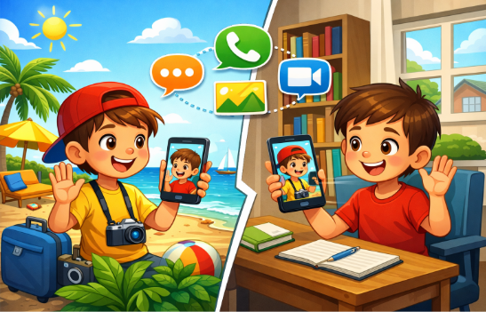
With just a few taps, the app will help you:
• Send messages
• Share photos and videos
• Make voice or video calls
Even when people are far away, apps help us stay connected.
Apps are like digital helpers inside our phones.
Now tell me, which app do you mostly use to talk to your friends and relatives?

A mobile app is a software application on phones or tablets that helps us do different tasks easily.
They help us:
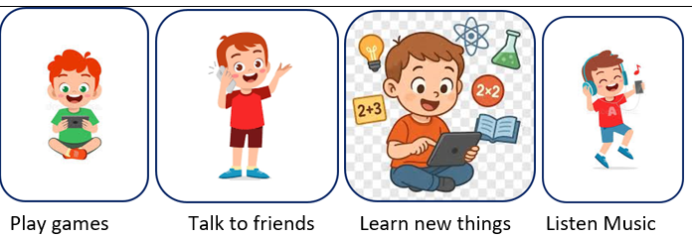
• Some apps need the internet, while others can work without it.
For example, the Alarm App does not need internet, and the YouTube App requires internet to watch videos.
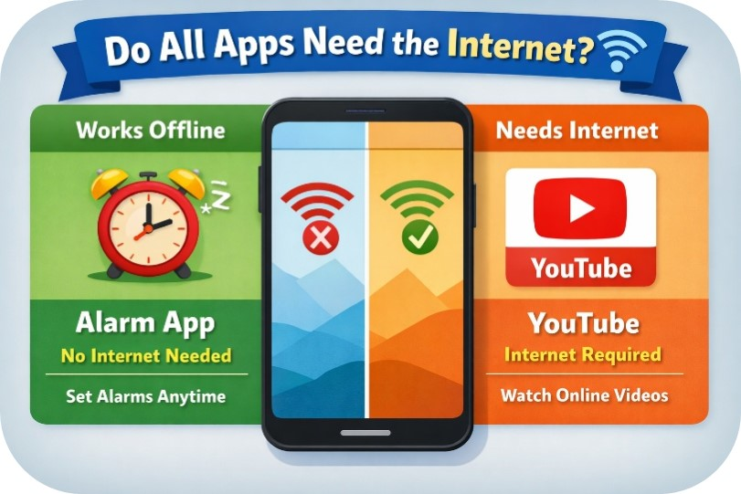

When you tap a button, the app follows a set of instructions. First, it takes your action as an input, then processes it, and finally shows you the result as an output.
Every app works using a simple process:
User Action → App Instruction → Result
This is also called:
Input → Process → Output
Example:
Input: You type a message and press Send
Process: The app sends the message
Output: Your friend receives the message
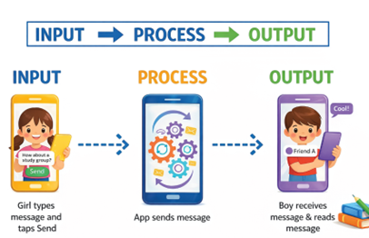
ACTIVITY TIME
Look at the apps shown and try to identify the names of these apps.


Planning helps the app become easy and fun to use. Every app is created through four simple phases.
Phase 1 – Idea 💡
The problem the app will solve. Example: App to remind students to drink water.
Phase 2 – Planning 📝
Decide screens, buttons and actions.
Phase 3 – Design & Build 🛠
Create screens and write code.
Phase 4 – Test & Improve 🔍
Check the app and fix mistakes.
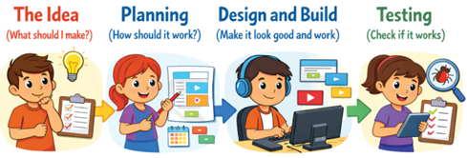

Summary
• Apps are software programs that run on mobile devices
• Apps help us perform many daily tasks easily
• Apps work using Input → Process → Output
• App designers follow four phases: Idea → Planning → Design & Build → Test & Improve

2. Lec: App Builder Platform

Apps are created using App Builder Platforms.
An App Builder Platform is a software tool that helps us design app screens, add buttons and images, and create working apps.
It is like a digital workspace where ideas turn into apps.
When designing an app, creators focus on two important things.
1. UI - User Interface
UI includes all the things you can see and tap in an app.
Examples: Buttons, Icons, Labels, and Screens
2. UX - User Experience
UX is about how easy and smooth the app feels to use.
A good UX makes an app simple, clean, and easy to use
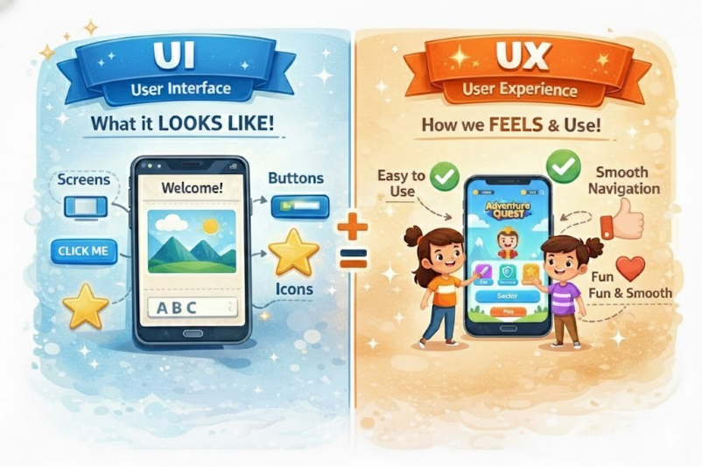

In this course, you will build apps using the WizKlub App Builder Platform.
The WizKlub App Builder is a beginner-friendly platform.
Instead of writing long code, you can drag and drop widgets, design app screens, and add blocks to make the app work. This makes app creation easy and fun!
The WizKlub App Builder has two important modes.
1. Designer Mode 🎨
Used to design the app screen.
Here you can:
• Create screens
• Add buttons and labels
• Change colours and text
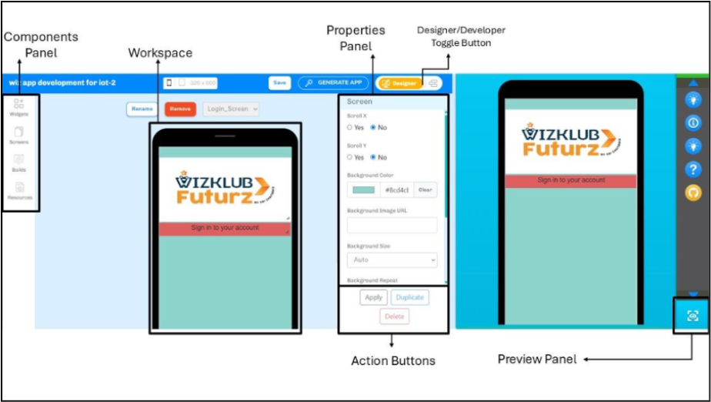
2. Developer Mode 💻
Used to add logic to the app.
Here you decide:
• What happens when a button is clicked
• How the app behaves
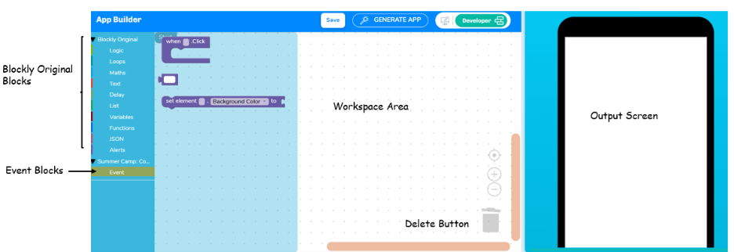

Summary
- Apps are created using App Builder Platforms
- UI shows the visible parts of the app
- UX makes the app easy to use
- WizKlub App Builder has Designer Mode and Developer Mode
- Apps are built using Screens and Widgets

